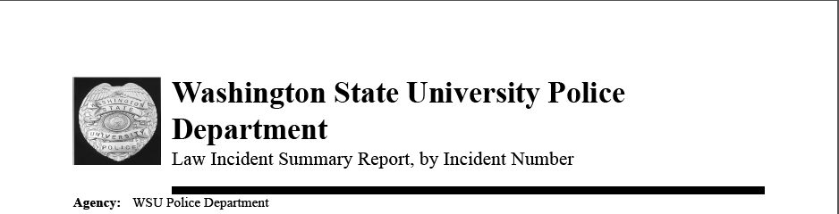

16-W2639 Escort NR 05/27/16

Incident Address : 1040 NE Colorado St; Parking Services

PULLMAN WA 99163

Time Reported: 10:36 05/26/16

Time Occurred between: 10:36:35 05/26/16 - 10:36:35 05/26/16

Narrative:

Officer performed a security detail.

16-W2640 Welfare Check CLO 05/26/16

Incident Address : PULLMAN, WA 99163

Time Reported: 11:01 05/26/16

Time Occurred between: 10:57:34 05/26/16 - 10:57:34 05/26/16

Narrative:

Officer provided and agency assist for the Pullman Police Department.

16-W2641 Escort NR 05/27/16

Incident Address : 1815 NE Wilson Rd; French Administration

PULLMAN WA 99163

Time Reported: 11:09 05/26/16

Time Occurred between: 11:09:30 05/26/16 - 11:09:30 05/26/16

Narrative:

Officer performed a security detail.

16-W2642 Suspicious Person/Circumstance ACT 05/26/16

Incident Address : 405 NE SPOKANE ST; SLOAN HALL

PULLMAN WA 99163

Time Reported: 13:14 05/26/16

Time Occurred between: 13:10:51 05/26/16 - 13:10:51 05/26/16

Narrative:

Officer dispatched to a report of suspicious activity.

16-W2643 Elevator Alarm NR 05/27/16

Incident Address : 1820 NE WILSON RD; JOHNSON ELEV 1

PULLMAN WA 99163

Time Reported: 13:18 05/26/16

Time Occurred between: 13:17:28 05/26/16 - 13:17:34 05/26/16

Narrative:

Officer responded and determined the elevator was clear and operational.

16-W2644 Elevator Alarm NR 05/27/16

Incident Address : 1845 E GRIMES WAY; BUSTAD

PULLMAN WA 99163

Time Reported: 13:42 05/26/16

Time Occurred between: 13:42:24 05/26/16 - 13:42:26 05/26/16

Narrative:

Officer responded and determined the elevator was clear and operational.

16-W2645 Burglary/Intrusion Alarm NR 05/27/16

Incident Address : 1400 NE Terrell Mall; Holland Library

PULLMAN WA 99163

Time Reported: 17:10 05/26/16

Time Occurred between: 17:10:08 05/26/16 - 17:10:08 05/26/16

Narrative:

Received an emergency alarm on the exit door during business hours. No officer response needed during business hours.

16-W2646 Burglary/Intrusion Alarm ACT 05/26/16

Incident Address : 1500 NE TERRELL MALL; Barnes & Noble

PULLMAN WA 99163

Time Reported: 19:10 05/26/16

Time Occurred between: 19:09:51 05/26/16 - 19:09:51 05/26/16

Narrative:

Officer dispatched to an alarm. Area was checked and no emergency was found.

16-W2647 Communications Problem CLO 05/27/16

Incident Address : 1265 SE STADIUM WAY; STEPHENSON E

PULLMAN WA 99163

Time Reported: 21:48 05/26/16

Time Occurred between: 21:45:33 05/26/16 - 21:46:14 05/26/16

Narrative:

Officer dispatched to an accidental 911 dial. No emergency was found.

16-W2648 Extra Patrol NR 05/27/16

Incident Address : 2480 NE Roundtop Dr; NRC Dodgen Research

PULLMAN WA 99163

Time Reported: 23:54 05/26/16

Time Occurred between: 23:54:45 05/26/16 - 23:54:45 05/26/16

Narrative:

Officer responded for a security check and found building to be secure.

16-W2649 Welfare Check TRA 05/27/16

Incident Address : 1445 NE NORTH FAIRWAY RD

PULLMAN WA 99163

Time Reported: 00:10 05/27/16

Time Occurred between: 00:08:16 05/27/16 - 00:08:16 05/27/16

Narrative:

Officer dispatched to a welfare check.

16-W2650 Extra Patrol NR 05/27/16

Incident Address : BEAR FACILITY

PULLMAN WA 99163

Time Reported: 01:11 05/27/16

Time Occurred between: 01:11:16 05/27/16 - 01:11:16 05/27/16

Narrative:

Officer responded for a security check and found building to be secure.

16-W2651 Extra Patrol NR 05/27/16

Incident Address : 1400 NE TERRELL MALL; Holland Library;

PULLMAN WA 99163

Time Reported: 01:41 05/27/16

Time Occurred between: 01:41:11 05/27/16 - 01:41:11 05/27/16

Narrative:

Officer responded for a security check and found building to be secure.

16-W2652 Unsecure Premise CLO 05/27/16

Incident Address : 3700 NE TERRE VIEW DR

PULLMAN WA 99163

Time Reported: 02:04 05/27/16

Time Occurred between: 02:03:56 05/27/16 - 02:03:56 05/27/16

Narrative:

Officer responded to an unsecured premise. Area was checked and premise was

secured.